**CRM-based workforce management system**

**A COMMUNITY CONNECT PROJECT REPORT**

Submitted by

S.M SRAVYA (RA2211030050012)

RAMYA K (RA2211030050037)

ALFRED RAJU (RA2211030050034)

MENTOR NAME

Dr. SHANMUGASUNDARI

In Partial Fulfillment of the Requirements

for the Degree of

**BACHELOR OF TECHNOLOGY**

in

**COMPUTER SCIENCE AND ENGINEERING WITH SPECIALIZATION IN**

**CYBER SECURITY**

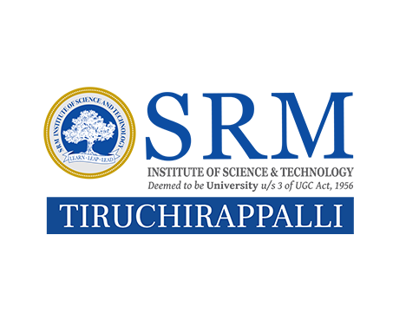

**SCHOOL OF COMPUTING**

**FACULTY OF ENGINEERING AND TECHNOLOGY**

**SRM INSTITUTE OF SCIENCE AND TECHNOLOGY**

**TIRUCHIRAPPALLI – 621105**

**July 2024**

**SRM INSTITUTE OF SCIENCE AND TECHNOLOGY**

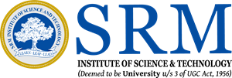

TIRUCHIRAPPALLI

TIRUCHIRAPPALLI

**COLLEGE OF ENGINEERING AND TECHNOLOGY**

**REGISTER NO:RA2211030050012,RA2211030050037,**

**RA2211030050034**

**BONAFIDE CERTIFICATE**

Certified as the bona fide record of work done by S.M.SRAVYA, MOHAMED IBRAHIM K, RAMYA.K Register NO:RA22110300050012,RA22110300500019,RA2211030050037 of V/3rd (Semester/Year), B.Tech. CSE W/S CYBER SECURITY

Programme in the project-based course **21GNP301L, Community Connect** at **SRM Institute of Science and Technology, Tiruchirappalli** during the Academic Year 2024-2025.

**Faculty In-charge Head of the Department**

Submitted for the End Semester Examination held on

**Examiner 1 Examiner 2**

# PROBLEM STATEMENT

In many rural and suburban areas, the transportation infrastructure is often underdeveloped, lacking both cost-effective and well-designed systems. This limitation significantly impacts the mobility of residents, making it difficult for them to access essential services like healthcare, education, and employment. The absence of durable and sustainable bus stops further exacerbates this issue, leaving commuters exposed to harsh weather conditions, which in turn affects the reliability and attractiveness of public transportation. Without proper bus shelters, people face discomfort and delays, deterring the use of public transit and contributing to a reliance on private vehicles or limited alternatives.

To address this gap, there is a pressing need for an innovative, affordable, and environmentally friendly solution that enhances the quality and accessibility of community transport services, particularly in underdeveloped regions. This project aims to design and implement a low-cost bus stop model that not only offers shelter and comfort to commuters but also integrates eco-friendly materials and practices. By improving the commuting experience and fostering sustainable transportation options, the project seeks to enhance public transit systems and provide long-term benefits to both the community and the environment.

|  |  |  |
| --- | --- | --- |
|  | **TABLE OF CONTENTS** |  |
| **CHAPTER NO.** | **TITLE** | **PAGE NO.** |
| **1.** | **RELEVANCE TO SDG**  **OBJECTIVE OF CHOOSING THE SPECIFIC CATEGORY NGO**  **ABOUT VIVEKA ARACKATTALAI**  **PROBLEM IDENTIFICATION**  **PROBLEM STATEMENT**  **WEEKWISE ACTIVITIES TAKEN**  **DETAILED IMPLEMENTATION REPORT OF THE PROJECT** | **1**  **1**  **2**  **2**  **2**  **3** |

|  |  |  |  |
| --- | --- | --- | --- |
|  | 1.1 | ABSTRACT | 4 |
|  | 1.2 | INTRODUCTION | 4 |
|  | 1.3  1.4  1.5  1.6 | RELATED WORK  BACKGROUND  IMPLEMENTATION  CONCLUSION | 5  6  7  8 |
| **2.** | **FUTURE SCOPE** | | **9** |
| **3.** | **TANGIBLE LEARNING** | | **10** |
| **4.**  **5.** | **OUR CONTRIBUTION TO THE NGO**  **REFERENCES** | | 11  17 |

**Relevance to SDG:**

**SDG 8: Decent Work and Economic Growth**

SDG 8 aims to promote sustained, inclusive, and sustainable economic growth, full and productive employment, and decent work for all. Your CRM-based workforce management system supports this goal by improving the operational efficiency of the NGO, which focuses on marginalized communities like women, transgenders, and children. In many NGOs, poor workforce management can lead to inefficiencies, limiting their impact and hindering the empowerment of vulnerable groups.

By streamlining resource allocation, task management, and beneficiary tracking, the system helps the NGO optimize its workforce and expand its services. This increased efficiency allows the NGO to provide more effective vocational training and job opportunities, directly contributing to decent work and economic inclusion for underserved populations. Moreover, the system reduces administrative burdens, allowing staff and volunteers to focus on delivering impactful programs that promote economic empowerment and growth, helping communities become more self-sufficient and resilient.

**Objective of Choosing the Specific Category NGO:**

We chose Viveka Arackattalai, an NGO focused on supporting marginalized communities, such as women, transgenders, and children, because of the vital role they play in society. These vulnerable groups face systemic disadvantages that limit their access to essential services, employment opportunities, and societal acceptance. The NGO’s efforts to uplift these communities through education, healthcare, and vocational training are commendable but hampered by operational inefficiencies. Our objective in selecting this NGO category was to help them overcome these challenges, particularly in managing their workforce effectively, thereby enhancing their capacity to deliver services efficiently and maximize their positive societal impact.

Our project aimed to solve the manpower management issue through a CRM-based workforce management system. We recognized that addressing this specific problem would lead to better resource allocation, task management, and beneficiary tracking, thereby helping the NGO increase its impact without overburdening its staff or volunteers.

**About Viveka Arackattalai:**

Viveka Arackattalai is a non-profit organization dedicated to empowering marginalized groups in India, with a particular focus on women, transgenders, and children. Their mission is to provide education, healthcare, and vocational training to these communities, enabling them to gain employment, achieve financial independence, and integrate more fully into society. The NGO serves around 5000 beneficiaries annually with a staff of 150 members, working across multiple programs and initiatives.

The organization’s services include:

* **Education Programs**: Providing basic education and vocational training to women and children to help them build skills and improve employability.
* **Healthcare Services**: Offering medical check-ups, health awareness campaigns, and facilitating access to medical care for marginalized groups.
* **Employment Initiatives**: Training and placement programs that aim to empower women and transgender individuals to find sustainable employment.
* **Support for Transgender Communities**: Viveka Arackattalai offers support programs specifically designed to address the challenges faced by the transgender community, including discrimination, lack of employment opportunities, and access to healthcare.

While Viveka Arackattalai has a far-reaching impact, their current challenge is managing their staff and volunteers to ensure that resources are allocated effectively and that beneficiaries receive consistent support.

**Problem Identification:**

Despite its wide-reaching impact, Viveka Arackattalai faces significant challenges in managing its workforce and resources. The organization has 150 staff members who serve more than 5000 beneficiaries annually. The staff is involved in diverse programs, but the manual processes used to allocate tasks, track beneficiary outcomes, and manage volunteers lead to inefficiencies. This results in:

* **Overworked staff**: Staff members are often assigned tasks without considering their current workload, leading to burnout.
* **Resource Misallocation**: Limited visibility into real-time resource allocation leads to gaps in service coverage, where some tasks receive excessive attention while others are neglected.
* **Inconsistent Service Delivery**: Beneficiaries may not receive timely or appropriate services due to inefficient tracking and follow-up mechanisms.
* **Volunteer Underutilization**: Volunteers are often not matched to tasks based on their skills, reducing the effectiveness of their contribution.

The need for a centralized system to manage the staff and volunteers, track beneficiary progress, and provide real-time data for decision-making became evident during our initial discussions with the NGO’s leadership.

**Problem Statement:**

The primary challenge for Viveka Arackattalai is the inefficient allocation of manpower and resources. This challenge is exacerbated by the manual nature of their operations, which involves handling task assignments, tracking service delivery, and managing volunteers. The absence of a centralized system means that staff members are often overburdened, volunteers are not utilized effectively, and there is little visibility into how resources are being used. As a result, the NGO struggles to deliver consistent, high-quality services to its beneficiaries.

To address this, we proposed the development of a **CRM-based workforce management system** that would streamline operations by automating task allocation, tracking beneficiary outcomes, and managing volunteers. This system would reduce the administrative burden on staff, optimize resource use, and improve service delivery.

**Week-wise Activities Undertaken by Us**

**Week 1: Initial Visit and Problem Identification**

Our initial engagement with Viveka Arackattalai involved an in-depth visit to their main offices and outreach locations. During this visit, we observed the operational workflows, interacted with staff members, and understood the various programs and services the NGO offers. We identified the primary challenge of workforce management and discussed potential technology-driven solutions. This visit provided crucial insights into the organizational structure and the gaps in their current processes, setting the foundation for our project.

**Week 2: Research and Project Conceptualization**

In the second week, we conducted extensive research on existing CRM systems tailored for non-profits and their workforce management needs. We explored various technical options and features that could address the NGO’s challenges. After several brainstorming sessions, we conceptualized a **CRM-based workforce management system** designed specifically for NGOs. This system would include modules for:

* **Task allocation** based on staff availability and skill sets.
* **Beneficiary tracking** to monitor service delivery.
* **Volunteer management** to optimize resource utilization.
* **Data analytics** for real-time decision-making and reporting.

**Week 3: Planning and Design**

During week three, we focused on detailed planning and design. This phase involved:

* **System architecture design**: We mapped out the architecture for the CRM system, deciding on cloud-based infrastructure to ensure scalability and accessibility.
* **Workflow design**: We designed workflows for various modules, such as task management, beneficiary tracking, and volunteer management.
* **UI/UX design**: User interface prototypes were created to ensure ease of use for the NGO staff, with a focus on intuitive navigation and minimal training requirements. We also engaged with the NGO's leadership to refine the system based on their feedback.

**Week 4: Community Engagement and Feedback**

In the final phase of the project, we actively engaged with both the NGO staff and the beneficiaries to gather feedback on the proposed solution. We presented the CRM design and demonstrated how it would address their current challenges. The feedback we received was instrumental in refining the system, particularly in the areas of user interface design and task management workflows. This phase ensured that the system would not only meet technical requirements but also align with the operational needs of the staff.

**Detailed Implementation Report of the Project**

**Abstract:**

This report presents the design and implementation of a CRM-based workforce management system for Viveka Arackattalai, an NGO that supports marginalized groups such as women, transgender individuals, and children. With over 150 staff members serving approximately 5,000 beneficiaries annually, the NGO faces significant challenges in workforce and resource management. The inefficiencies in task allocation and beneficiary tracking have hindered their ability to consistently provide high-quality services.

The proposed CRM system addresses these issues by centralizing data management, automating task distribution, and enhancing communication among staff, volunteers, and beneficiaries. Key features include beneficiary tracking, task management, volunteer coordination, and data analytics. The system also includes a communication platform to streamline internal and external interactions, fostering better engagement with beneficiaries.

This report details the problem identification process, the design and development of the CRM system, and the results expected from its implementation. We also outline the tangible learning outcomes of the project, our contributions to the NGO, and the future scope for further improvements. Ultimately, the system aims to enhance operational efficiency, service delivery, and the long-term scalability of Viveka Arackattalai’s programs, enabling them to better fulfill their mission of social impact.

**Introduction:**

Non-governmental organizations (NGOs) play a crucial role in addressing social issues, particularly in supporting marginalized communities. However, these organizations often operate with limited resources, making the efficient management of staff, volunteers, and beneficiaries essential to their success. Viveka Arackattalai is an NGO dedicated to empowering vulnerable groups by providing essential services such as education, healthcare, and employment opportunities. However, the growing demand for their services has exposed inefficiencies in workforce and resource management, leading to inconsistent service delivery.

To tackle these operational challenges, this project aimed to develop a CRM-based workforce management system tailored to the specific needs of Viveka Arackattalai. The system was designed to centralize workforce and beneficiary data, automate task allocation, and improve communication across all levels of the organization. By implementing this system, the NGO could significantly enhance its operational efficiency, ensure equitable workload distribution, and track the outcomes of services provided to beneficiaries more effectively.

This report documents the process of designing, implementing, and evaluating the CRM system, outlining how the solution addresses the key operational challenges faced by Viveka Arackattalai. It also explores the broader implications of CRM systems in the NGO sector and how they can be leveraged to improve service delivery and organizational impact.

**Related Work:**

The use of technology to streamline NGO operations has gained significant attention in recent years, particularly in the area of customer relationship management (CRM) systems. While CRM systems have traditionally been associated with business organizations, their applicability in the social sector is now being explored as NGOs seek more effective ways to manage their workforce, volunteers, and beneficiaries.

Several studies have shown the benefits of CRM systems in improving efficiency and transparency in non-profit organizations. For instance, research by Choudhury et al. (2020) highlights how CRM tools have been successfully implemented in NGOs to manage donor relationships, track volunteer engagement, and monitor the delivery of services. This has allowed NGOs to scale their operations while reducing administrative overhead.

Similarly, Bhatnagar et al. (2019) demonstrated the effectiveness of workflow automation in non-profit environments, showing how the reduction of manual processes through CRM systems resulted in better service delivery and increased beneficiary satisfaction. These systems also provide real-time data analytics, enabling organizations to make data-driven decisions.

However, despite the potential benefits, many NGOs are slow to adopt CRM systems due to cost concerns, lack of technical expertise, and resistance to change. Viveka Arackattalai faced similar challenges, which is why this project focused on designing a cost-effective, user-friendly CRM system tailored to their specific needs. Our solution builds on the best practices of existing CRM implementations while addressing the unique challenges faced by NGOs.

This project also draws on prior research in workforce management and task allocation in the social sector. Studies have shown that NGOs with well-managed staff and volunteer coordination are better equipped to provide consistent and high-quality services (Kumar & Desai, 2018). The CRM system developed for Viveka Arackattalai incorporates these insights by automating task distribution based on staff availability and skills, ensuring that tasks are allocated efficiently and without overburdening individual employees.

**Background:**

Viveka Arackattalai, founded in 2010, is an NGO based in India that focuses on supporting marginalized communities, including women, children, and transgender individuals. Their services range from education and healthcare to vocational training and employment opportunities. Over the years, Viveka Arackattalai has grown rapidly in response to increasing demand for their services. With a small workforce of around 150 employees and hundreds of volunteers, they currently support over 5,000 beneficiaries annually.

Despite their impactful work, the rapid expansion of their programs has led to several operational challenges. One of the most significant issues is the inefficiency in manpower management. Due to the lack of an organized system, task allocation has often been ad-hoc, leading to uneven workloads, staff burnout, and gaps in service delivery. Furthermore, the absence of a centralized data system for tracking beneficiaries and services provided has made it difficult for the NGO to measure the impact of their programs or respond quickly to evolving community needs.

Additionally, the NGO has struggled to engage and manage its large pool of volunteers effectively. Without a dedicated system for matching volunteer skills with available tasks, many volunteers have been underutilized, while some areas of the NGO’s operations remain understaffed.

Recognizing these challenges, our project aimed to design and implement a CRM-based workforce management system tailored to the needs of Viveka Arackattalai. The goal was to improve workforce efficiency, optimize resource allocation, and enhance the quality of services delivered to beneficiaries. Our solution would centralize data management, automate task assignments, and provide analytics to support better decision-making.

The CRM system was conceptualized as a comprehensive solution that would not only streamline internal processes but also facilitate communication between staff, volunteers, and beneficiaries. The system was developed using open-source technologies to ensure that it would be cost-effective and scalable, enabling the NGO to expand its operations without being limited by budget constraints.

This background section highlights the core operational challenges faced by Viveka Arackattalai, which served as the foundation for the development of the CRM system. It also provides context on the NGO’s mission and operations, helping to understand why the chosen technical solution is critical to their future growth and success.

**Implementation:**

The CRM-based workforce management system includes the following key components:

1. **Centralized Database**: The CRM system serves as a centralized hub for storing data on staff, beneficiaries, volunteers, and services. This ensures that all information is accessible in real-time and can be updated as needed.
2. **Task and Workforce Allocation**: The system includes a task management module that automatically allocates tasks to staff members based on their availability, skills, and current workload. This prevents overburdening any one staff member and ensures that tasks are completed in a timely manner.
3. **Beneficiary Tracking**: The CRM tracks the services provided to each beneficiary, including healthcare, education, and vocational training. It also monitors outcomes, allowing the NGO to assess the effectiveness of its programs.
4. **Volunteer and Resource Management**: The system manages the NGO’s volunteers by matching their skills with appropriate tasks. It also tracks their engagement and availability, ensuring that volunteers are utilized efficiently.
5. **Training and Cross-Skilling**: The CRM tracks the training and development of staff members, enabling them to take on multiple roles as needed. This ensures that the NGO has a flexible workforce capable of handling a wide range of tasks.
6. **Data Analytics and Reporting**: The system generates real-time reports on staff efficiency, task completion, beneficiary outcomes, and volunteer engagement. These insights allow the NGO to make data-driven decisions and improve service delivery.
7. **Custom Workflow Automation**: The CRM automates repetitive tasks, such as sending updates, scheduling events, and monitoring task progress. This reduces the administrative burden on staff and frees up time for more strategic activities.
8. **Communication Platform**: The system integrates communication tools such as email and messaging, ensuring that staff members, volunteers, and beneficiaries can communicate seamlessly.

**Conclusion:**

The CRM-based workforce management system designed for Viveka Arackattalai addresses critical operational challenges by automating task allocation, improving resource management, and providing real-time data for decision-making. The system is expected to enhance service delivery, prevent staff burnout, and increase the NGO’s capacity to serve its beneficiaries. By implementing this system, Viveka Arackattalai can continue to grow its impact and provide much-needed support to marginalized communities.

**FUTURE SCOPE:**

The CRM-based workforce management system implemented for Viveka Arackattalai offers a solid foundation for streamlining their operations, but there is considerable potential for future expansion and enhancement. Several areas can be explored to further optimize the system and enable the NGO to continue scaling its impact:

1. **Integration with Mobile Platforms:** Developing a mobile app version of the CRM would enable staff and volunteers to access the system remotely. This would be particularly useful for field staff working directly with beneficiaries in remote areas, allowing them to update data, track progress, and manage tasks on the go.
2. **AI and Data-Driven Decision-Making:** Incorporating AI tools for predictive analysis could help anticipate staffing needs and resource allocation based on historical data. For example, AI could predict times of increased demand for healthcare services or education programs, allowing the NGO to plan and allocate resources more effectively.
3. **Real-Time Beneficiary Feedback Mechanism:** By introducing a feedback system directly into the CRM, beneficiaries could provide real-time feedback on the services they receive. This feedback could be used to assess the quality of services, identify gaps, and implement improvements quickly.
4. **Volunteer Engagement Portal:** An expansion of the system to include a volunteer engagement portal where volunteers can sign up for tasks, track their contributions, and receive performance feedback would increase volunteer retention. This portal could also serve as a recruitment tool for new volunteers and donors.
5. **Donor and Fundraising Integration:** Integrating donor management and fundraising capabilities into the CRM system could streamline the NGO's efforts to engage with donors and manage donations. This would include automated donation tracking, communication with donors, and reporting on the impact of funds received.
6. **Scalability for Multiple NGOs:** The CRM system, currently tailored for Viveka Arackattalai, could be further developed as a generic solution for NGOs in similar sectors. By making it customizable for different organizations, it can become a scalable product that other NGOs can adopt to improve their operations.
7. **Integration with Government and Other NGOs:** The system could be integrated with government databases and other NGOs’ platforms, allowing for collaboration in delivering services, sharing beneficiary data, and coordinating relief efforts during crises or high-demand periods.

**TANGIBLE LEARNING:**

Our involvement in the design and implementation of the CRM-based workforce management system provided several valuable and tangible learning experiences. Key learnings include:

1. **Project Management in Real-World Settings:** Working with an NGO introduced us to the complexities of managing a large workforce and diverse operations in a non-profit environment. Understanding their challenges with limited resources, and translating these into technical requirements, provided a hands-on lesson in project management and solution development.
2. **User-Centric Design and Development:** We learned the importance of involving end-users (the NGO staff) in the design process to ensure that the CRM system would be intuitive and meet their needs. This experience reinforced the significance of user feedback in iterative design and development, particularly in social sector projects.
3. **Problem-Solving in a Resource-Constrained Environment:** Developing solutions within the constraints of a non-profit organization’s budget and infrastructure helped us refine our problem-solving skills. We had to prioritize features that would deliver the most value without overburdening the NGO with high costs or overly complex solutions.
4. **Collaboration and Communication Skills:** Interacting with various stakeholders at the NGO—ranging from leadership to field staff—enhanced our ability to communicate technical ideas to non-technical audiences. This was critical for ensuring the NGO’s buy-in and for successful implementation of the system.
5. **Understanding of Non-Profit Operations:** We gained deep insights into how NGOs operate, particularly in how they manage people, deliver services, and measure impact. This experience broadened our perspective on the unique challenges faced by social sector organizations compared to corporate environments.
6. **System Design for Social Impact:** Developing a system that would directly contribute to social impact allowed us to appreciate the role that technology can play in solving real-world issues. We also learned how technology can enhance operational efficiency and increase the reach of NGOs, helping them make a greater difference in society.

**Our Contribution to the NGO:**

Our contribution to Viveka Arackattalai goes beyond simply delivering a technical solution. We sought to enhance their ability to serve marginalized communities by providing a comprehensive system that addresses their core operational challenges. Key contributions include:

1. **Improved Workforce Efficiency:** By automating task allocation, tracking staff workloads, and managing volunteers, the CRM system enables the NGO to optimize its workforce. This ensures that tasks are completed on time, resources are allocated appropriately, and staff members are not overburdened.
2. **Enhanced Service Delivery:** The beneficiary tracking module ensures that the NGO can monitor the services provided to each beneficiary and assess their progress over time. This improves service delivery by enabling more personalized and timely interventions, leading to better outcomes for the beneficiaries.
3. **Optimized Volunteer Management:** Our system matches volunteers with tasks based on their skills, ensuring they are utilized effectively. By tracking volunteer engagement and performance, the NGO can better manage its volunteer pool and increase overall productivity.
4. **Real-Time Reporting and Analytics:** With real-time insights into staff efficiency, task completion, and beneficiary outcomes, the NGO can make data-driven decisions to improve service delivery. This reporting capability also aids in transparency for stakeholders and donors, allowing the NGO to demonstrate its impact more effectively.
5. **Long-Term Scalability:** The system is designed with scalability in mind, allowing the NGO to expand its operations without overwhelming staff or resources. As the organization grows, the CRM can accommodate more users, tasks, and beneficiaries, ensuring that operations remain smooth and efficient.
6. **Training and Skill Development:** As part of our implementation process, we trained the NGO staff on how to use the CRM system. This not only empowers them to manage their tasks more effectively but also provides them with valuable skills in using technology to enhance their day-to-day operations.
7. **Sustainable Operations:** By reducing manual processes and automating key workflows, we helped the NGO reduce the administrative burden on its staff. This leads to more sustainable operations, where staff can focus more on delivering services and less on managing paperwork and logistics.
8. **Increased Capacity for Impact:** Our CRM-based solution enables Viveka Arackattalai to extend its reach and serve more beneficiaries without adding significant overhead costs. By streamlining their operations, the NGO can increase the number of beneficiaries it supports while maintaining or even improving the quality of services.

Our contributions helped Viveka Arackattalai optimize its workforce, improve service delivery, and create a foundation for future growth and sustainability. Through this project, we enabled the NGO to scale its impact and continue its mission of supporting marginalized communities.

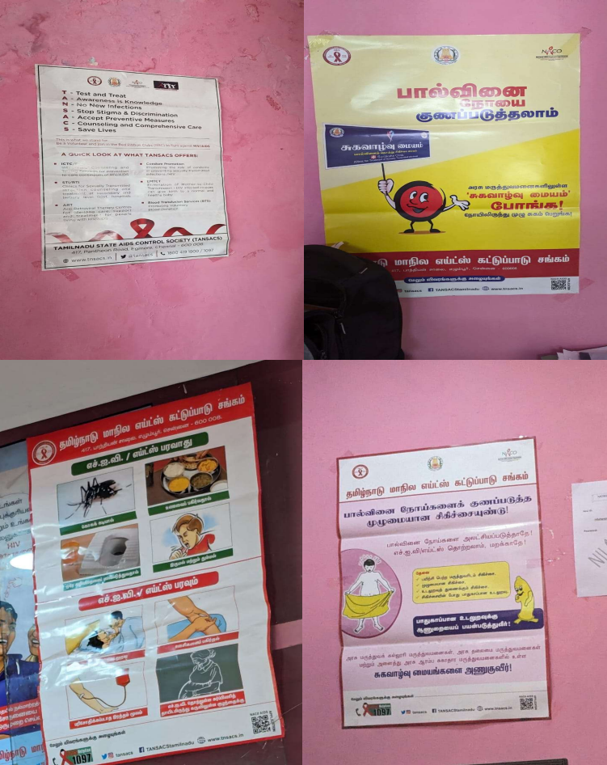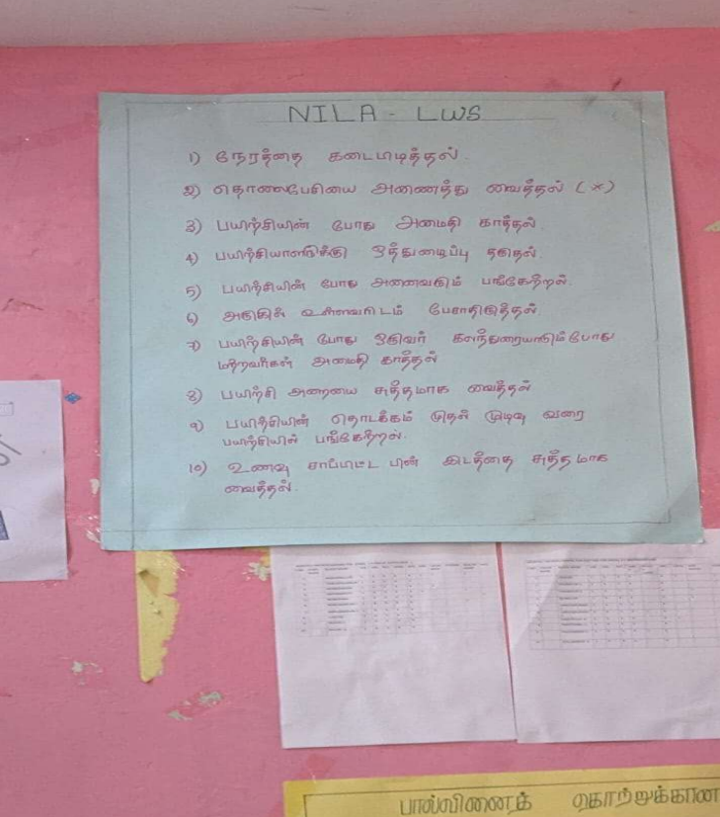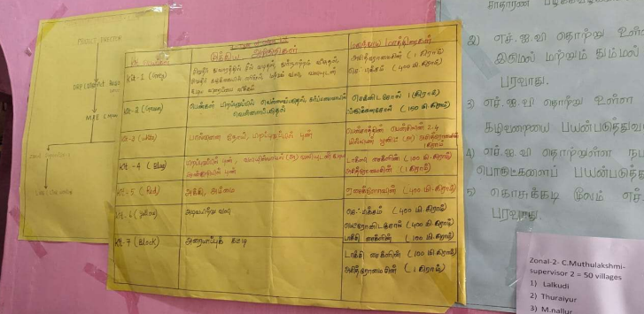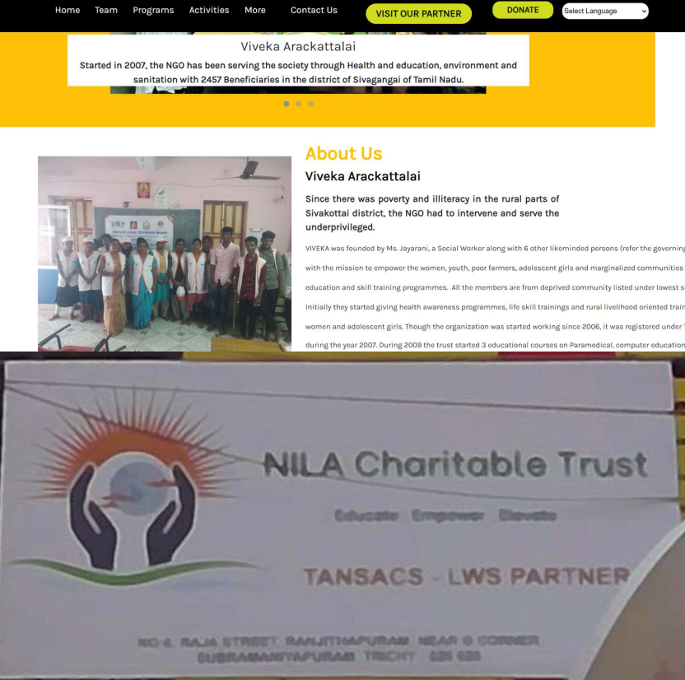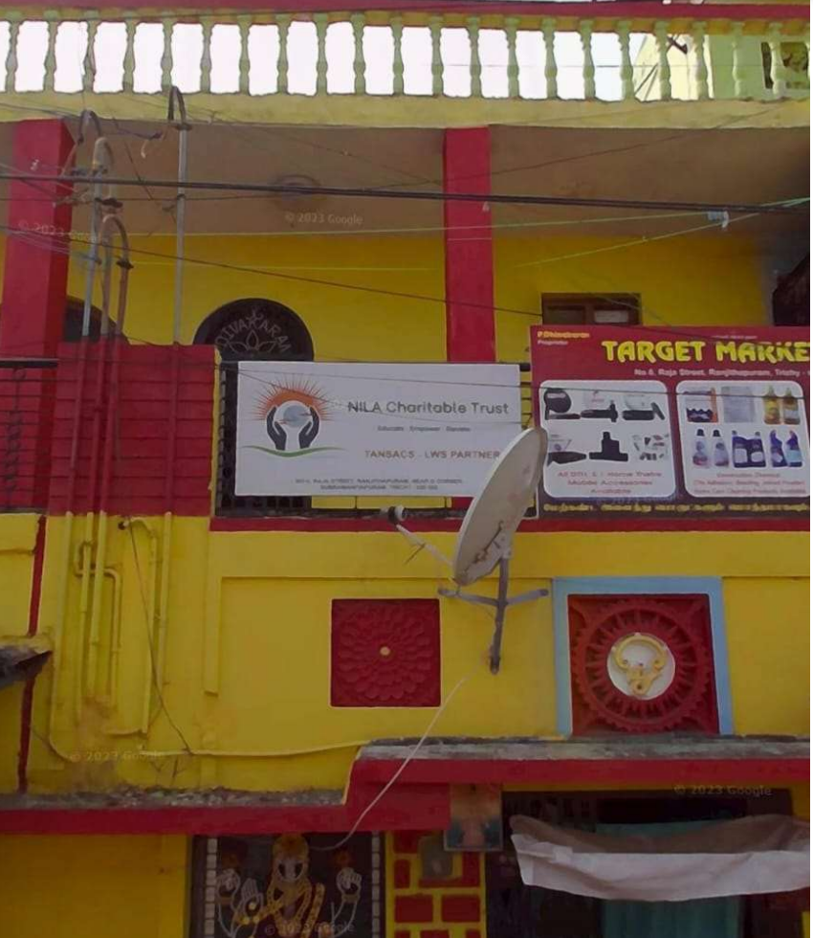

**References:**

* 1. Salesforce.org. (2022). "CRM for Nonprofits: A Complete Guide." <https://www.salesforce.org/nonprofit/crm/>
  2. Forbes. (2020). "The Role of CRM in Nonprofit Organizations." <https://www.forbes.com/sites/forbestechcouncil/2020/10/01/the-role-of-crm-in-nonprofit-organizations/>
  3. Maddox, C. (2019). "Managing Volunteers Effectively with CRM Tools." Nonprofit Quarterly. <https://nonprofitquarterly.org/managing-volunteers-effectively-with-crm-tools/>
  4. Harrison, B. (2021). "Beneficiary Management Systems for NGOs: Using CRM to Track Impact." Social Impact Journal.
  5. Meier, L. (2018). "Implementing CRM in Nonprofits: Case Studies of Successful CRM Adoption." Journal of Nonprofit Technology.
  6. Kumar, R. & Mahajan, A. (2020). "Digital Solutions for Nonprofits: How Technology Is Transforming NGO Operations." International Journal of Social Work and Human Services Practice.